**Java Web开发**

**实验七**

**作业报告**

|  |  |
| --- | --- |
| 学 院 | 计算机 |
| 所在系 班 级 | 2017软件工程系9班 |
| 学 号 姓 名 | 03170919陈智健 |
| 指 导 教 师 | 罗永升 |
| 完 成 时 间 | 2019年4月27日 |

# 实验题目

页面输入收入，得到相应的缴纳税收,要求：Jsp提交收入，显示结果（可一个页面也可两个页面）。编写一个JavaBean计算税收，并在JSP页面输出结果,计算方法：全月应纳税所得额＝月收入－1600元,级数 全月应纳税所得额 税率% 速算扣除法(元) 1 dr <=500 5 0

1. 2 500 <dr<=3000 10 25
2. 3 3000 < dr <=5000 15 125
3. 4 5000 < dr <=20000 20 375
4. 5 20,000 < dr <=40000 25 1375
5. 6 40,000 < dr <=60,000 30 3375
6. 7 60,000 < dr <=80,000 35 6375 8 80,000 < dr <=100,000 40 10375 9 dr >100,000元 45 15375
7. 如：月收入3000，则（3000-1600）*10%-25=115，因为3000-1600大于500小于2000，所以按10%计算后再扣除速算的部分。

# 分析与设计

根据题目要求，计划设计几个文件来完成实验，每个文件的名字、作用。如果是类，要求写出类的变量和方法

# 关键源码（部分）

**package** test7;

**public** **class** Salary {

**int** salary;

**public** **int** getSalary() {

**return** salary;

}

**public** **void** setSalary(**int** salary) {

**this**.salary = salary;

}

**public** **float** salarycout(**int** salary) {

**int** FinallyIncome = 0;

**int** check=salary-1600;

**if**(check>0&&check<=500)

{

FinallyIncome=(**int**) (check*0.05);

}

**else** **if**(check>500&&check<=3000)

{

FinallyIncome=(**int**) (check*0.1-25);

}

**else** **if**(check>3000&&check<=5000)

{

FinallyIncome=(**int**) (check*0.15-125);

}

**else** **if**(check>5000&&check<=20000)

{

FinallyIncome=(**int**) (check*0.2-375);

}

**else** **if**(check>20000&&check<=40000)

{

FinallyIncome=(**int**) (check*0.25-1375);

}

**else** **if**(check>40000&&check<=60000)

{

FinallyIncome=(**int**) (check*0.3-3375);

}

**else** **if**(check>60000&&check<=80000)

{

FinallyIncome=(**int**) (check*0.35-6375);

}

**else** **if**(check>80000&&check<=100000)

{

FinallyIncome=(**int**) (check*0.4-10375);

}

**else** **if**(check>100000)

{

FinallyIncome=(**int**) (check*0.45-15375);

}

**return** FinallyIncome;

}

**public** **static** **void** main(String[] args) {

// **TODO** Auto-generated method stub

}

}

<%@ page language=*"java"* import=*"java.util.*"* pageEncoding=*"UTF-8"*%>

<%

String path = request.getContextPath();

String basePath = request.getScheme()+"://"+request.getServerName()+":"+request.getServerPort()+path+"/";

%>

<!DOCTYPE HTML PUBLIC "-//W3C//DTD HTML 4.01 Transitional//EN">

<html>

<head>

<base href=*"*<%=basePath%>*"*>

<title>My JSP 'input.jsp' starting page</title>

<meta http-equiv=*"pragma"* content=*"no-cache"*>

<meta http-equiv=*"cache-control"* content=*"no-cache"*>

<meta http-equiv=*"expires"* content=*"0"*>

<meta http-equiv=*"keywords"* content=*"keyword1,keyword2,keyword3"*>

<meta http-equiv=*"description"* content=*"This is my page"*>

<!--

<link rel="stylesheet" type="text/css" href="styles.css">

-->

</head>

<body>

<form action=*"salary.view"* method=*"post"*>

请输入你的薪水：<input type=*"text"* name=*"salary"*>

<input type=*"submit"* value=*"结算"*>

</form>

</body>

</html>

package test7;

import java.io.IOException;

import java.io.PrintWriter;

import javax.servlet.ServletException;

import javax.servlet.annotation.WebServlet;

import javax.servlet.http.HttpServlet;

import javax.servlet.http.HttpServletRequest;

import javax.servlet.http.HttpServletResponse;

@WebServlet("/salary.view")

public class SalaryServlet extends HttpServlet {

public void doGet(HttpServletRequest request, HttpServletResponse response) throws ServletException, IOException {

this.doPost(request, response);

}

public void doPost(HttpServletRequest request, HttpServletResponse response) throws ServletException, IOException {

Salary s=new Salary();

String salary=request.getParameter("salary");

int salary1=Integer.valueOf(salary);

float salary2=s.salarycout(salary1);

request.getSession().setAttribute("salary",salary2);

request.getRequestDispatcher("ShowSalary.jsp").forward(request, response);

}

}

<%@ page language=*"java"* import=*"java.util.*"* pageEncoding=*"UTF-8"*%>

<%@ page import=*"test7.Salary"*%>

<%

String path = request.getContextPath();

String basePath = request.getScheme()+"://"+request.getServerName()+":"+request.getServerPort()+path+"/";

%>

<!DOCTYPE HTML PUBLIC "-//W3C//DTD HTML 4.01 Transitional//EN">

<html>

<head>

<base href=*"*<%=basePath%>*"*>

<title>My JSP 'ShowSalary.jsp' starting page</title>

<meta http-equiv=*"pragma"* content=*"no-cache"*>

<meta http-equiv=*"cache-control"* content=*"no-cache"*>

<meta http-equiv=*"expires"* content=*"0"*>

<meta http-equiv=*"keywords"* content=*"keyword1,keyword2,keyword3"*>

<meta http-equiv=*"description"* content=*"This is my page"*>

</head>

<body>

你应交税为：<%=request.getSession().getAttribute("salary") %>

</body>

</html>

# 运行效果图

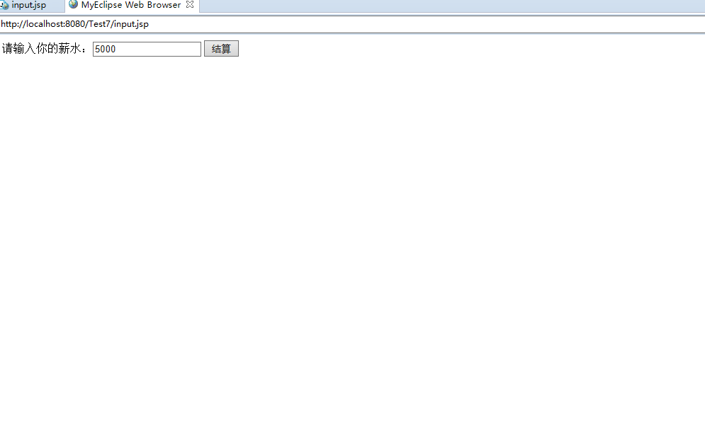

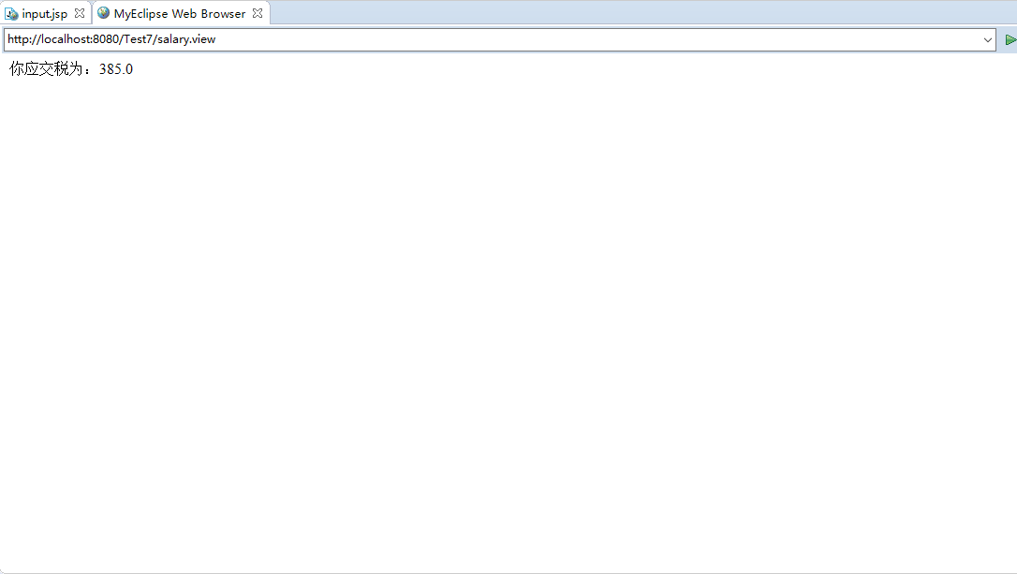

# 收获与问题

对javabean的掌握更深了